Creating a sample set of 25 observations resulted in a set that very closely resembled the original population but was either higher or lower by a few points. This is generally sufficient when looking to extrapolate from the original population.
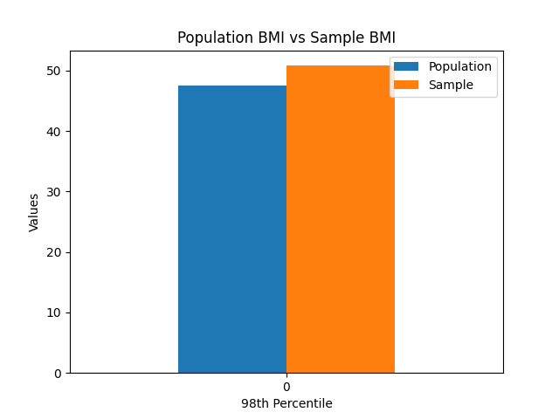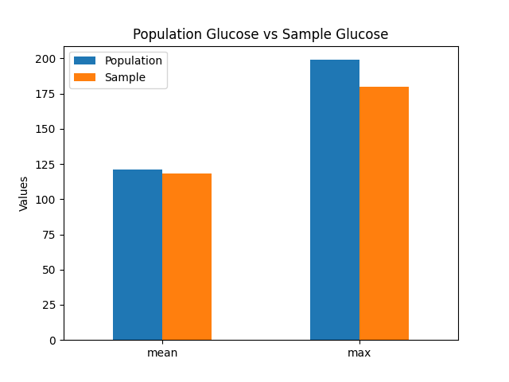
However, if more data is required and more data cannot be collected, bootstrapping proves to be an incredibly powerful tool. The bootstrapping method was implemented to create 500 samples with 150 observations each. When comparing the average mean, standard deviation, and 98th percentile of the 500 samples to the same statistics of the original population, the results are nearly identical with the 98th percentile of the population being slightly greater than the average of the bootstrapped samples.
